**PIZZA SALES SQL QUERIES**

**A) KPI’s**

1. Total_revenue

select SUM(total_price) as Total_revenue from pizza_sales

Output:-

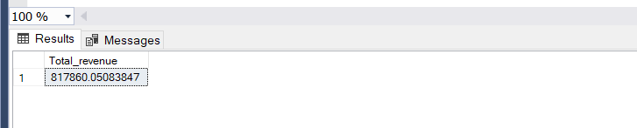

2. Average order value

select SUM(total_price)/COUNT(distinct order_id) as avg_order_value from pizza_sales

Output:-

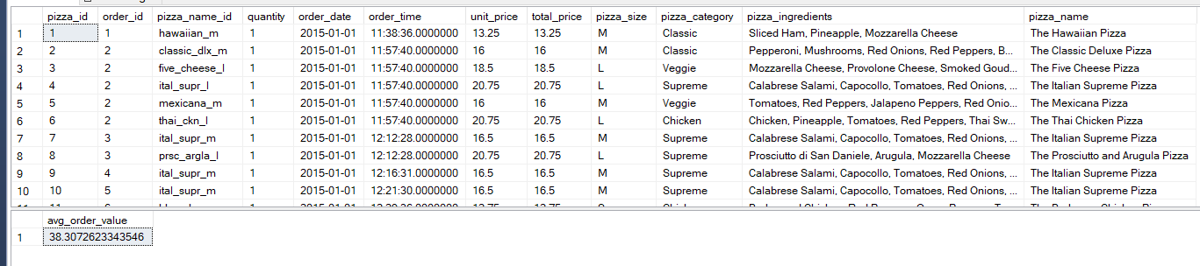

3. Total pizzas sold

select SUM(quantity) as Total_pizza_sold from pizza_sales

Output:-

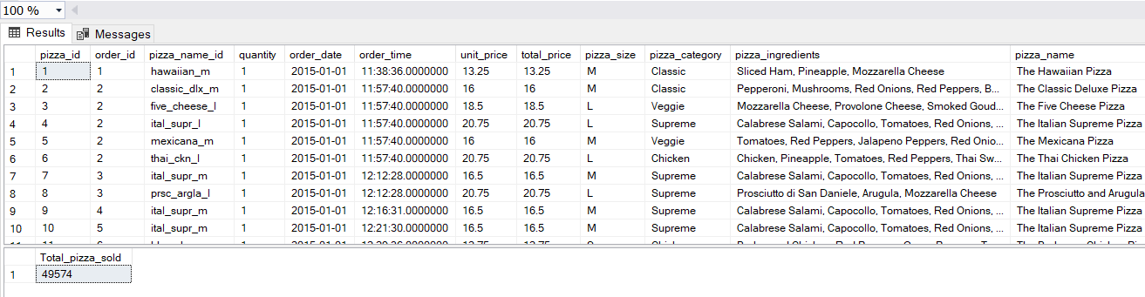

4. Total orders

select COUNT(distinct order_id)as total_orders from pizza_sales

Output:-

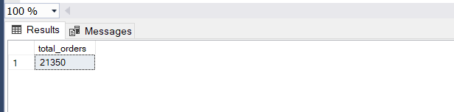

5. Average pizzas per order

select cast(CAST(SUM(quantity) as decimal(10,2))/

cast(COUNT(distinct order_id) as decimal(10,2)) as decimal(10,2)) as Avg_pizzas_perorder from pizza_sales

Output:-

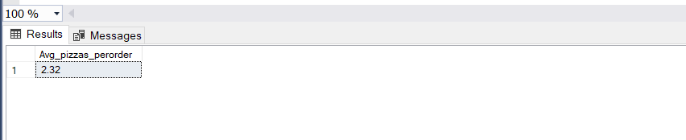

**B) Daily Trend for Total Orders**

select DATENAME(DW , order_date) as order_day, count(distinct order_id) as total_orders

from pizza_sales

group by DATENAME(DW, order_date)

Output:-

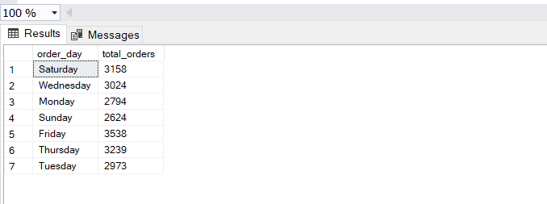

**C) Hourly Trend for Orders**

select DATENAME(Hour , order_time) as order_hours, count(distinct order_id)

as total_orders

from pizza_sales

group by DATENAME(Hour, order_time)

order by DATENAME(Hour, order_time)

Output:-

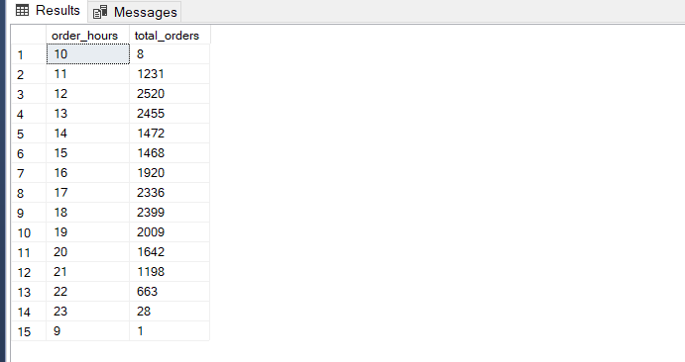

**D) % of sales by Pizza category**

select pizza_category,cast(sum(total_price) as decimal(10,2)) as total_revenue,

cast(sum(total_price)*100/(select sum(total_price) from pizza_sales)

as decimal(10,2)) as PCT

from pizza_sales

group by pizza_category

Output:-

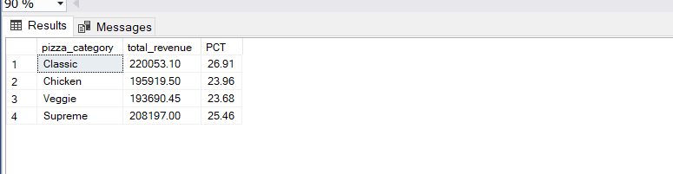

**E) % of sales by Pizza size**

select pizza_size,cast(sum(total_price) as decimal(10,2)) as total_sales, cast(sum(total_price) * 100/

(select sum(total_price) from pizza_sales) as decimal(10,2)) as PCT

from pizza_sales

group by pizza_size

order by pizza_size

Output:-

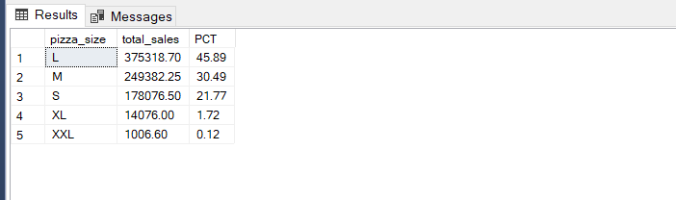

**F) Total pizzas sold by pizzas category**

select pizza_category,sum(quantity) as Total_Quantity_Sold

from pizza_sales

where month(order_date)=2

group by pizza_category

order by Total_Quantity_sold Desc

Output:-

